1)w.get("http://www.practiceselenium.com");

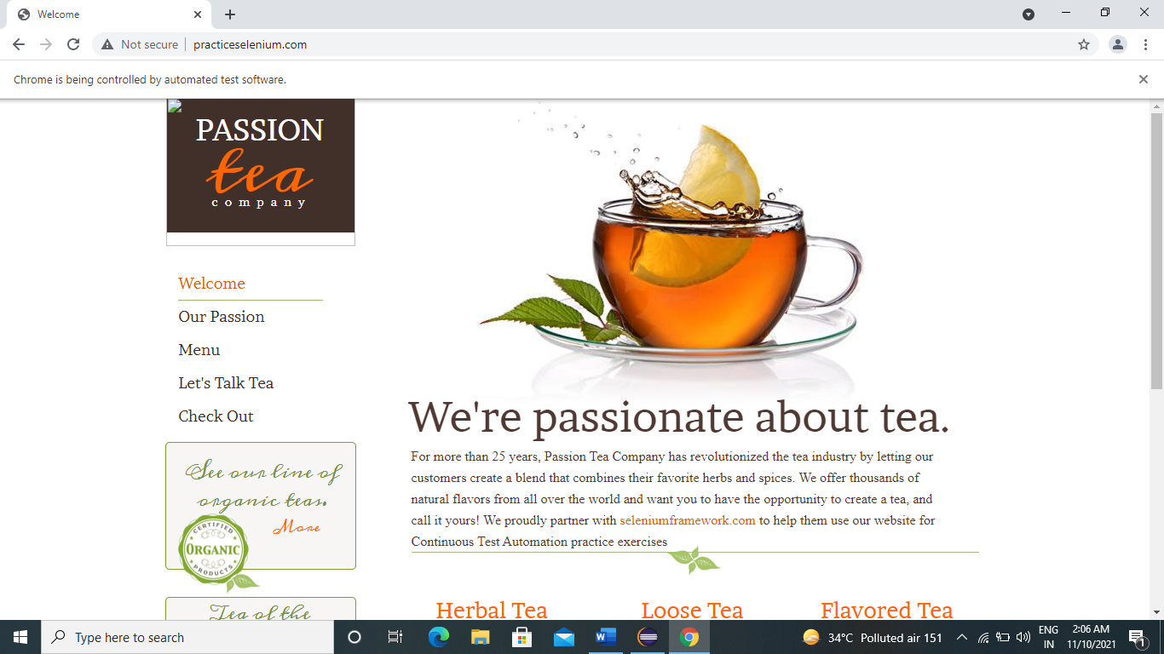

2)w.findElement(By.linkText("See Collection")).click();

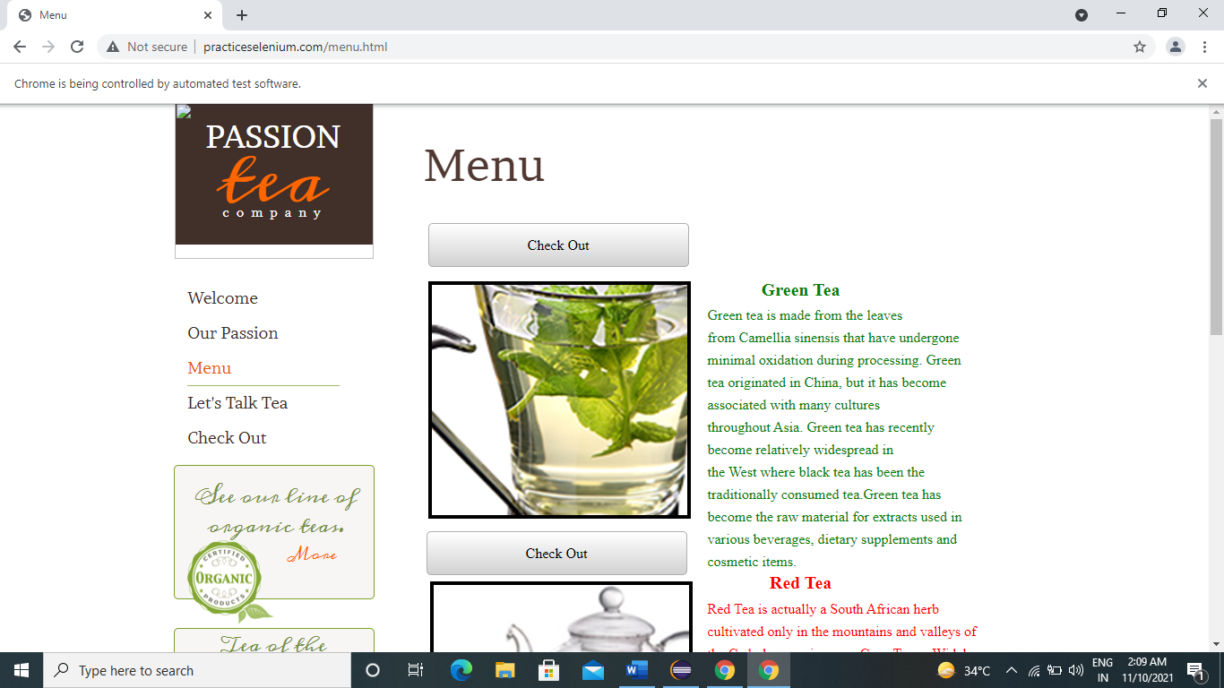

3)w.findElement(By.*linkText*("Check Out")).click();

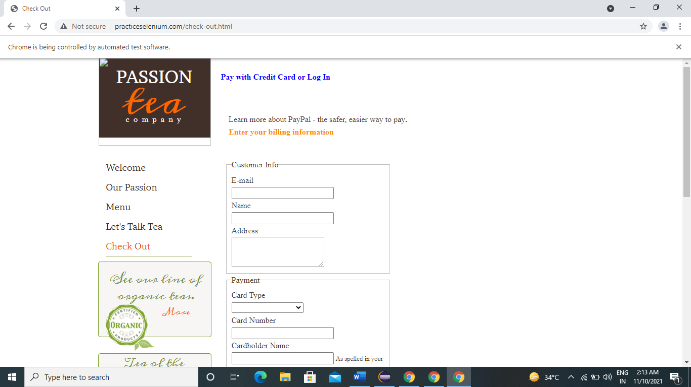

4)w.findElement(By.*id*("email")).sendKeys(" [nitishaaghav123@gmail.com](mailto:nitishaaghav123@gmail.com)");

5)w.findElement(By.*id*("name")).sendKeys("Nitisha Aghav");

6)w.findElement(By.*id*("address")).sendKeys("Sudama Bhel Pune");

7)Select s=**new** Select(w.findElement(By.*id*("card_type")));

s.selectByVisibleText("Mastercard");

8)w.findElement(By.*id*("card_number")).sendKeys("222-222-2222");

9)w.findElement(By.*id*("cardholder_name")).sendKeys("Nitisha Aghav");

10)w.findElement(By.*id*("verification_code")).sendKeys("122223");

11)w.findElement(By.*xpath*("//*[@id=\"wsb-element-00000000-0000-0000-0000-000452010925\"]/div/div/form/div/button")).click();

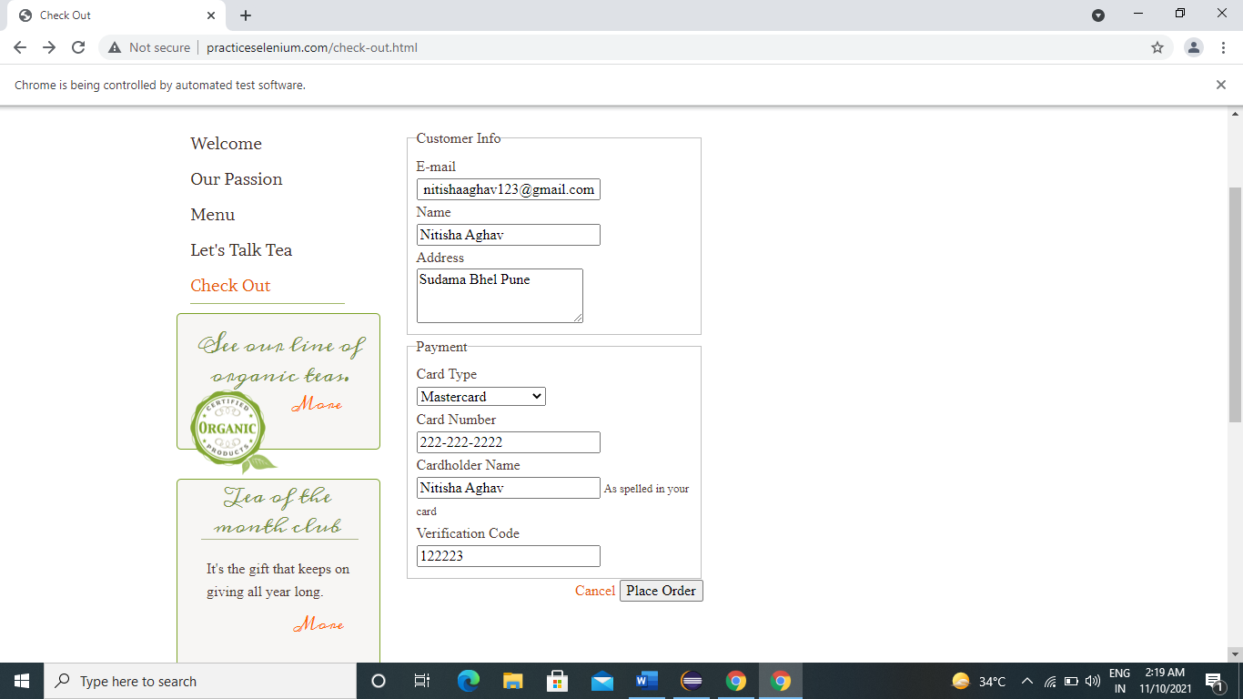

11)w.findElement(By.*linkText*("Check Out")).click();

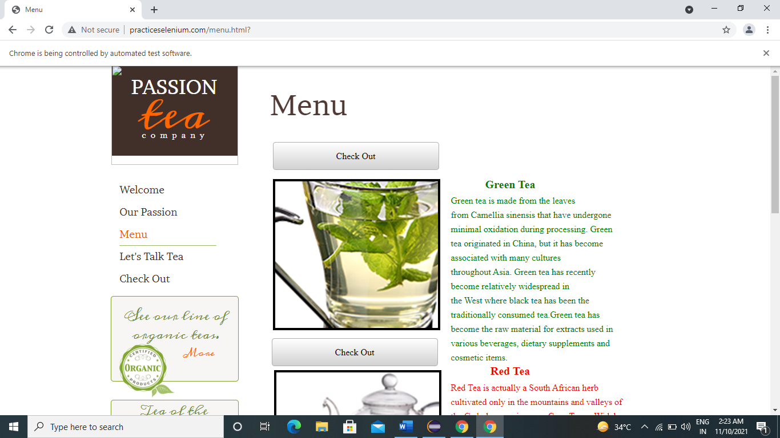

12) w.findElement(By.id("email")).sendKeys(" [nishaaghav123@gmail.com](mailto:nishaaghav123@gmail.com)");

13).findElement(By.id("name")).sendKeys("Tejas Aghav");

14)w.findElement(By.id("address")).sendKeys("Rahul Bhel Pune");

15)Select s1=**new** Select(w.findElement(By.id("card_type")));

s1.selectByVisibleText("Visa");

16)w.findElement(By.id("card_number")).sendKeys("333-333-333");

17)w.findElement(By.id("cardholder_name")).sendKeys("nisha Aghav");

18)w.findElement(By.id("verification_code")).sendKeys("132343");

19)w.findElement(By.xpath("//*[@id=\"wsb-element-00000000-0000-0000-0000-000452010925\"]/div/div/form/div/button")).click();

20)Thread.sleep(3000);

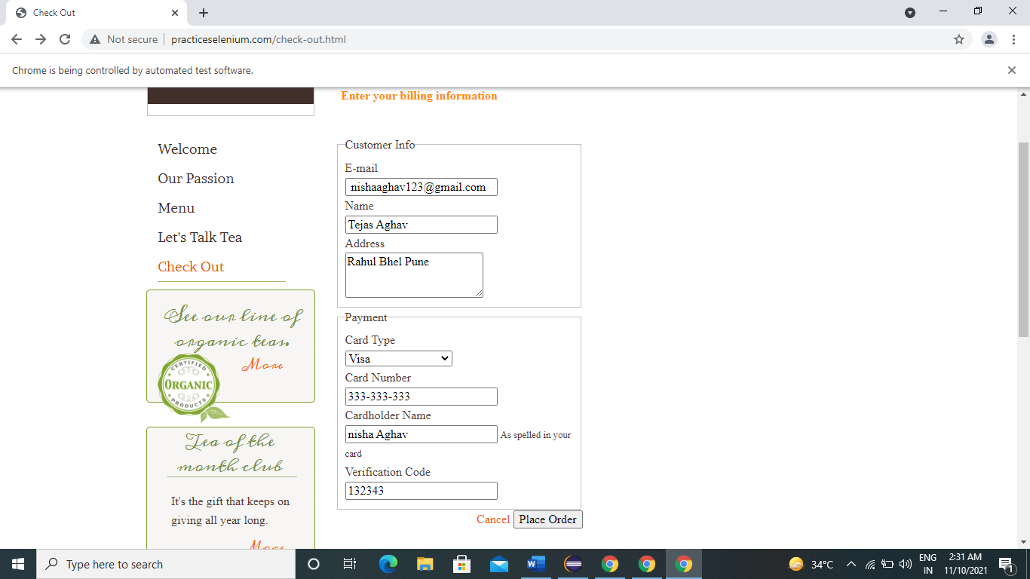

21)w.findElement(By.*linkText*("More")).click();

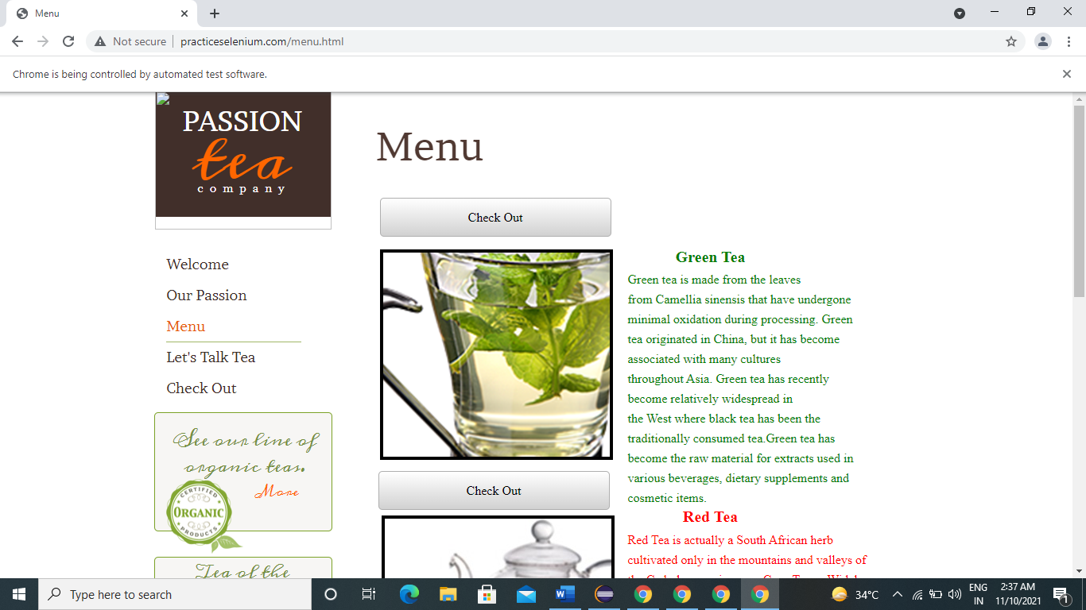

22) w.findElement(By.*xpath*("//*[@id=\"wsb-element-00000000-0000-0000-0000- 000450914882\"]/div/p/a/span")).click();

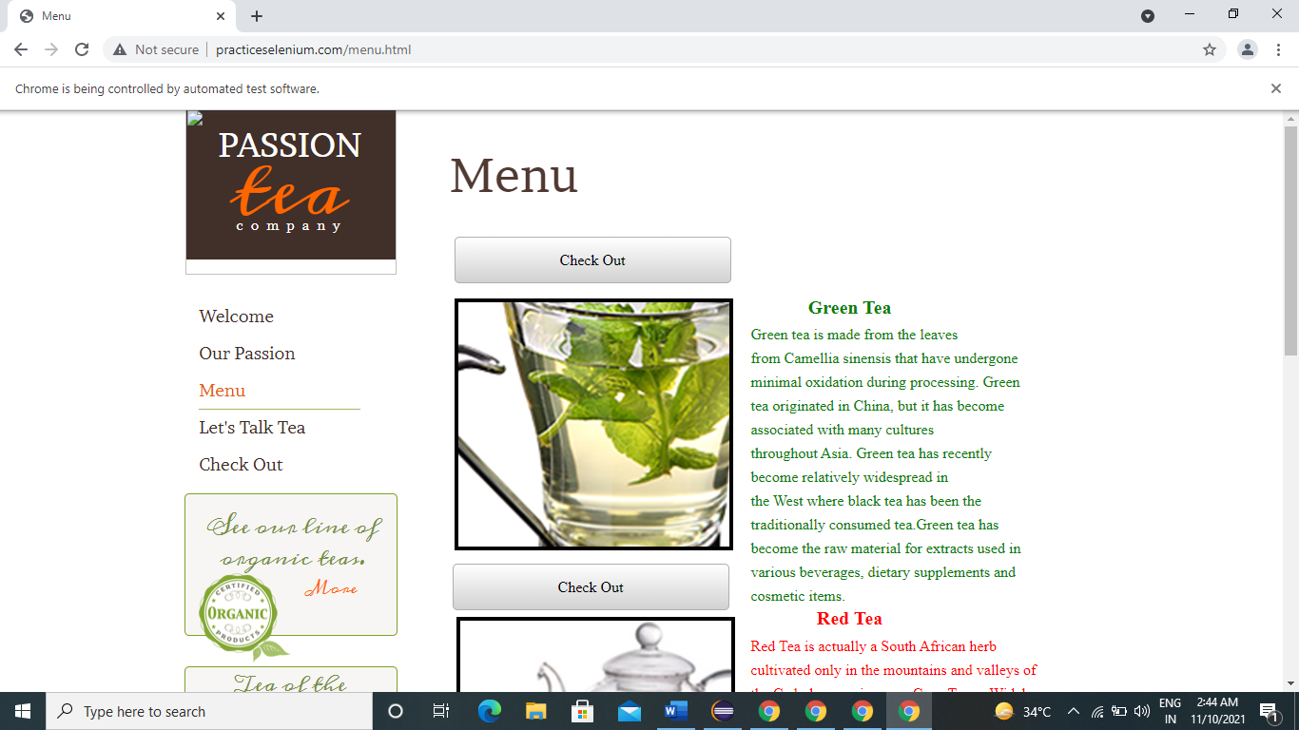

23)w.get("http://www.practiceselenium.com/");

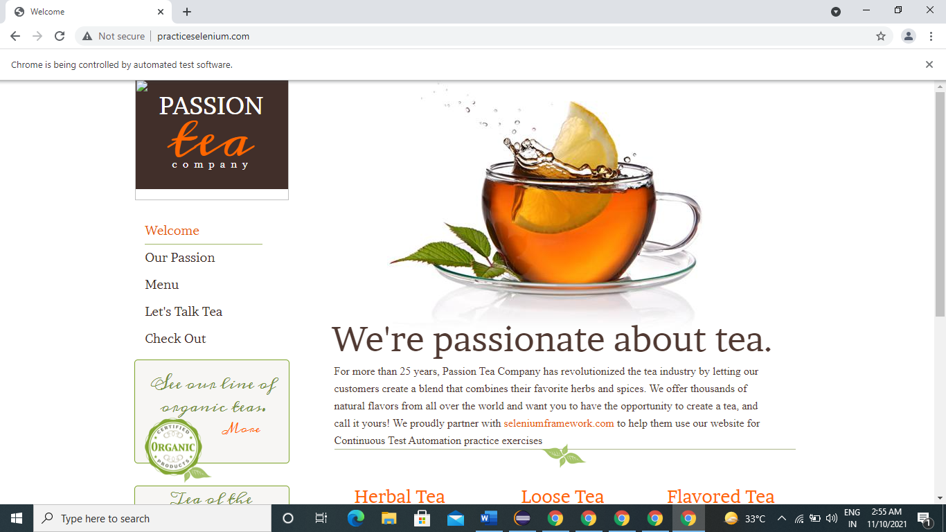

25)w.findElement(By.*linkText*("seleniumframework.com")).click();

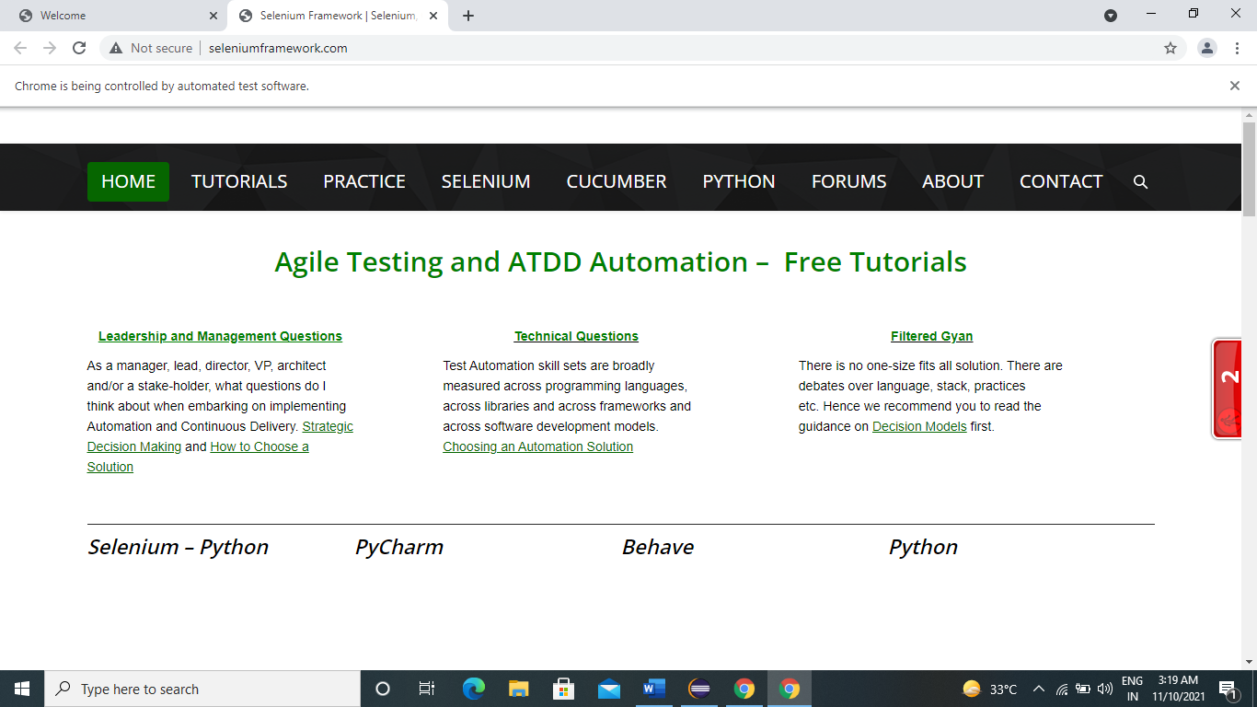

26)w.findElement(By.*linkText*("TUTORIALS")).click();

27)w.findElement(By.*linkText*("PRACTICE")).click();

28).findElement(By.*linkText*("SELENIUM")).click();

29)w.findElement(By.*linkText*("CUCUMBER")).click();

30)w.findElement(By.*xpath*("//*[@id=\"main-nav\"]/li[6]/a/span")).click();

31)w.findElement(By.*linkText*("ABOUT")).click();

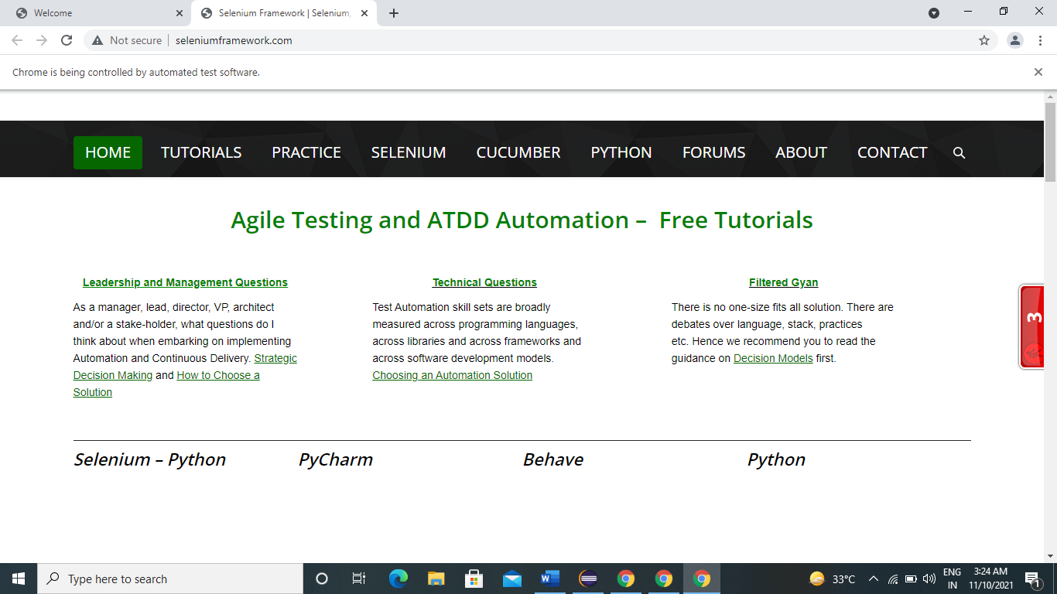

32)w.get("http://www.seleniumframework.com/");



33)w.findElement(By.*linkText*("ABOUT")).click();

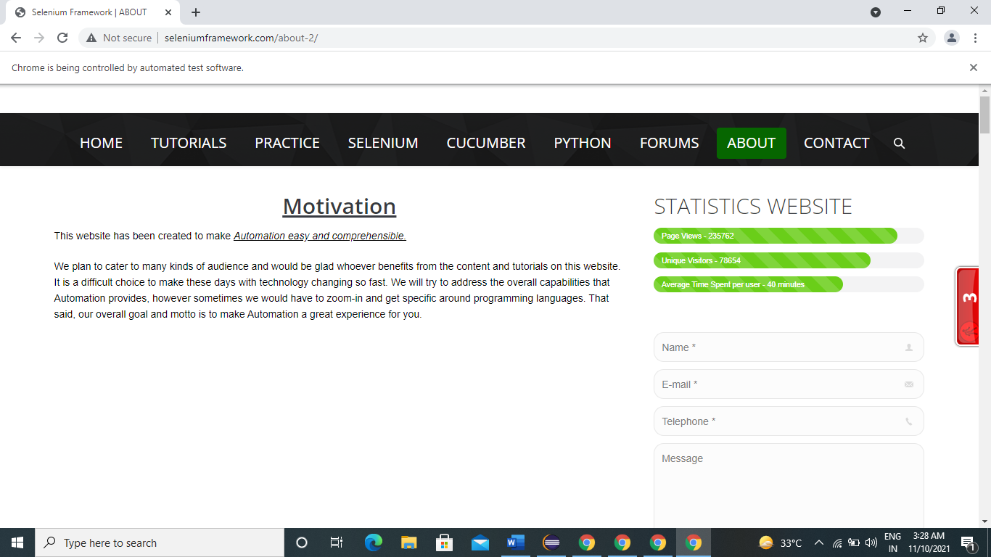

34) w.findElement(By.*name*("name")).sendKeys("Nisha");

35)w.findElement(By.*name*("email")).sendKeys("Nisha123@gmail.com");

36)w.findElement(By.*name*("telephone")).sendKeys("1212121212");

37)w.findElement(By.*name*("message")).sendKeys("I am fine");

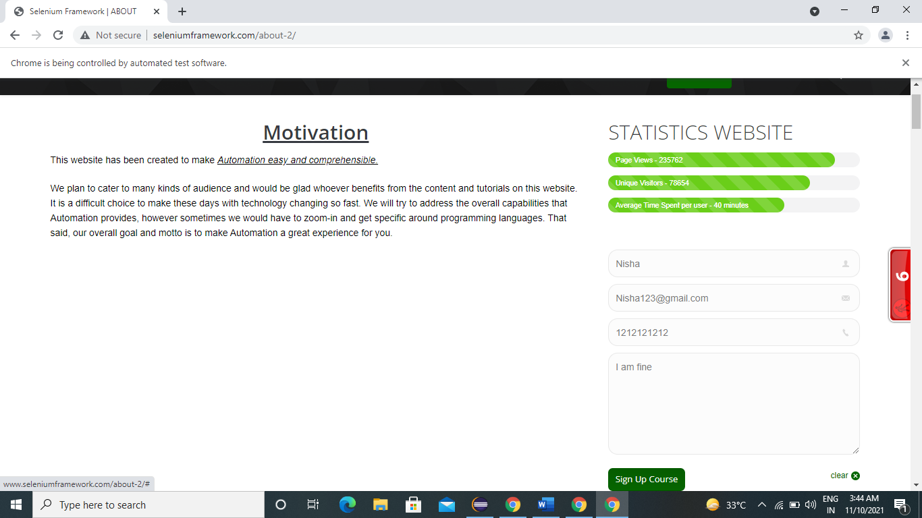

38)w.findElement(By.*linkText*("Sign Up Course")).click();

